Post-Meeting Notes 24/06

Model Description + Planning

The model should be able to provide insight into the effect that AP/cytokines levels are having on the speed of healing, level of scarring, and risk of infection. At one extreme, we have excessive scarring but low chance of infection, at the other, low scarring but high chance of infection. Depending on the dynamics of model / data there will be most likely be a ‘most effective’ level of AP/anti-inflammation to use in burn treatment. Mark is focusing on expanding the HIIS model by adding new relevant cell types. Ben is focusing on a 2-dimensional ABM simulating the cell migration.

Mark is focusing on this now:
At first, we will only create an abstract non-spatial interface with differential equations. The HIIS model will be expanded by adding cytokines and cell types related to the closure/contraction of the wound (cytokines: TGFB, PDGF, celltypes: Fibroblasts, Collagen, Myofibroblasts) to fill the gap between the HIIS and TUdelft contraction model. Differential equations will be built to model the relationship between the mentioned cytokines and cell types using these papers:

Macrophage Dynamics in Diabetic Wound Healing - Helen V. Waugh, 2006

Modeling the effects of treating diabetic wounds with engineered skin substitutes - Helen V. Waugh, PhD; Jonathan A. Sherratt, 2007

Modelling the interaction of keratinocytes and fibroblasts during normal and abnormal wound healing processes, Shakti N. Menon, 2012

The new implemented differential equations will look like:
Rate of change of cell Fibroblasts = cell migration + cell mitosis - cell death:
Similarly, the equations for TGF-b, PDGF and collagen will be determined using
Rate of change of chemical = chemical production - chemical decay

After implementing the new cell types, the model can/will be validated using data from Paul.

The expanded EBM model can serve as a setup for the TU Delft contraction model, providing the model with initial setups based on calculated fibroblast/myofibroblasts/collagen.

Example of expanded results:

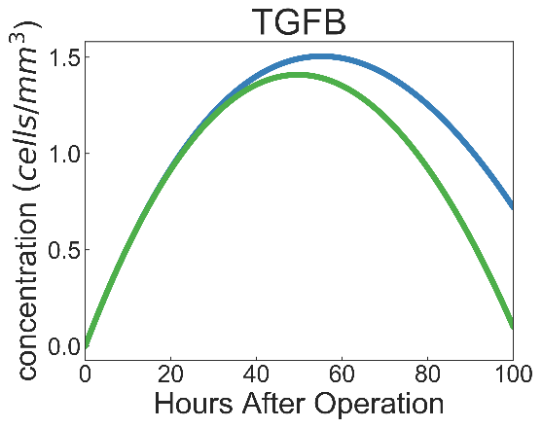
Ben is focusing on this now:
Two-Dimensional ABM with 2 areas, the first, at the edge of the wound where the cytokines in this area are input into the HIIS model (at first it will be initialized with values of the initially included cell types from the HIIS model (after mark is finished the fibroblasts, etc. can be included.), depending on level of AP, and not updated). Cell-Agents then migrate around the model (some affected by attractant gradients), having interactions.

TGFB (the first cytokine to be added) attractant gradients are the most relevant, fibroblasts move (and deposit) according to them. Since we have data on the amount of TGFB activated macrophages secrete, we can quite easily approximate the amount of TGFB in the wound and thus will be the first cytokine we focus on.

Mark’s abstract interface is the zone of blood exposure in the ABM, early experiments can ascertain the effect of different AP levels on the cytokine composition and subsequent healing. The cytokines in this tissue compartment will migrate across the wound, see paper (Weavers et al., 2016). Depending on the success of this implementation, we will then attempt to pass information from this zone to the HIIS model at certain timesteps. The model can also be extended to include the use of topical treatments such as anti-TGFB or Cerium Nitrate. Cytokines could also be allowed to move in/out of both zones, representing composition in surrounding skin (“hair follicles serve as reservoirs of skin mast cell precursors” - stem cell modulation is also being explored as a potential therapy).

Future extension: Hair follicles

Zone of Blood Exposure
Zone of No-Blood Exposure

In the future, these zones may be governed by reaction-diffusion equations, or extended for greater granularity

Cytokines / Fibroblasts / Macrophages

The zone of no-blood exposure can also be seen as an area of unresolved inflammation and therefore should also be causing some level of inflammatory cytokine production/triggering. Each cell, should also have a variable describing its oxygen content (e.g. macrophages stimulated by low O2 to induce angiogenesis). Can be extended to show cell death (by ischemia) at a threshold. The first version of our model will only look at AP → activated macrophages → TGFB distribution → Fibroblast/collagen deposit, using some metric to determine the risk of infection/level of scarring for each simulation.

Future Cytokine Inclusion

TNFa (pro-inflammatory) is also secreted by activated macrophages and TNFa suppression may also be used to slow down healing and reduce scarring. Higher concentrations of TNFa increase the fibroblast proliferation rate. It is increased in chronic wounds due to TNFa causing elevated metalloproteinases that degrade the local ECM and thus impair cell migration (Tarnuzzer and Schultz, 1996). It has also been used to stimulate angiogenesis, which makes it an attractive cytokine to model since we can extend design to include approximate angiogenesis dynamics, in the future.

TGFa (also secreted by activated macrophages) is a chemoattractant for keratinocytes (part of the reepithelisation process; epidermal keratinocytes can contribute to de novo hair follicle formation during large wound healing).

Both:
Angiogenesis
Angiogenesis will not be explicitly modeled. However, one only has to include pro-angiogenic factors to approximately model this, this governs the movement of the blood / no-blood exposure demarcation. As the model becomes more refined, blood flow/angiogenesis can be simulated with greater accuracy, either by looking at pro and anti-angiogenic factors that are part of the innate immune system or having further differentiated zones, or with reaction-diffusion equations. For now, angiogenesis will be simulated by adjusting the vascular permeability of areas,.

AP also has a large effect on barrier integrity, clearly it would have an impact on migration speeds yet we have not considered this. Cell migration and barrier integrity would therefore be a good candidate for model extension (and very novel). The effects will be modeled and illustrated after finishing the model.

Too much AP | ‘Godilocks’ AP | Too little AP
Little to No Scarring |  | Excessive Scarring
High Risk of Infection |  | Low Risk of Infection

Risk of infection
To ascertain the risk of infection, we will have to create a metric that includes factors as neutrophil count or neutrophil-bacteria ratio (mentioned in previous document). Excessive scarring could be seen as large dumps of collagen/fibroblasts, however, in the future would be nicer to test if the fibroblasts are laid down in “healthy” basket-weave orientation.

Level of Scarring

